|  |  |
| --- | --- |
| **Student Name:** | Maxwell Maia |
| **ID Number:** | 21236277 |
| **Degree Name:** | Bachelor of Science (Honours) in Computer Science and Information Technology |
| **Assessment:** | EE130 EEE-CA-1 |

# Continuous Assessment: Electrical/Electronic Innovators

## Description and purpose

You will learn about two Electrical & Electronic Engineering innovators and entrepreneurs through two videos.

The [first video](https://nuigalway.blackboard.com/bbcswebdav/pid-2106261-dt-content-rid-18364022_1/xid-18364022_1) about [Nikola Tesla](https://en.wikipedia.org/wiki/Nikola_Tesla) was recorded on 10th September 2020 with Professor W Bernard Carlson, Lecturer in TechInnovate (EEE, School of Engineering, NUI Galway) and Director of Engineering Business Programmes at the University of Virginia. Professor Carlson teaches on the Masters of AgInnovation and TechInnovation postgraduate programmes at NUI Galway.

[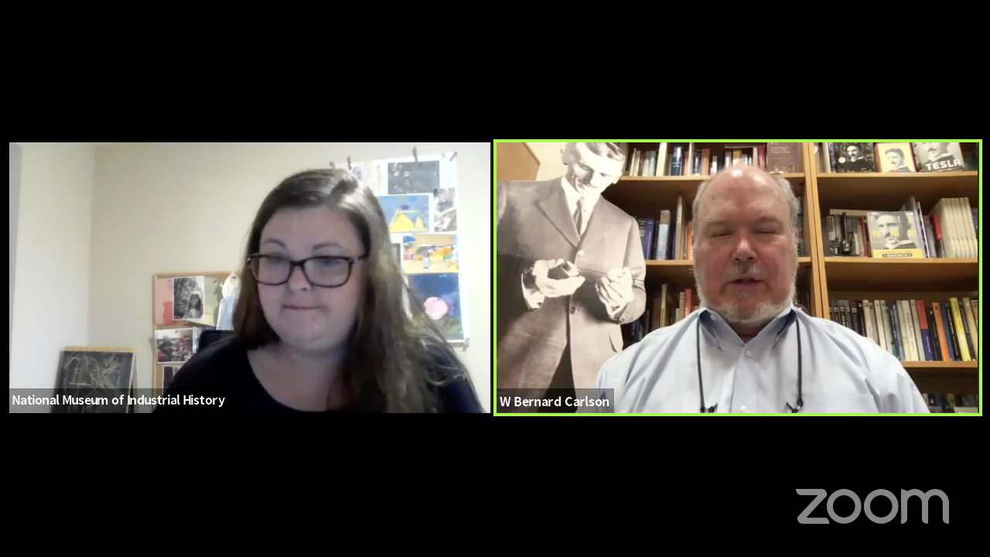](https://nuigalway.blackboard.com/bbcswebdav/pid-2106261-dt-content-rid-18364022_1/xid-18364022_1)

The [second video](https://nuigalway.blackboard.com/bbcswebdav/pid-2106261-dt-content-rid-18350992_1/xid-18350992_1) with Galway entrepreneur Shankar Ganesh Jayagopi, founder and CEO of [Magnus Monitors](https://www.magnusmonitors.com/), was recorded during an EI140 EEE lecture in 2019.

[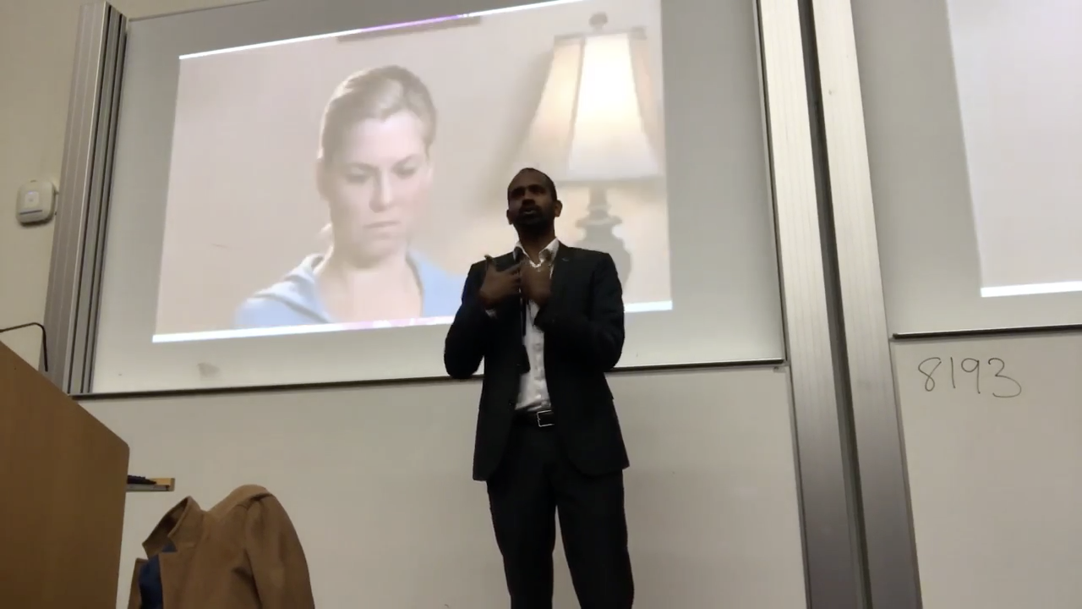](https://nuigalway.blackboard.com/bbcswebdav/pid-2106261-dt-content-rid-18350992_1/xid-18350992_1)

Please watch both of these videos and then answer the questions below. You may consult external resources as necessary, but please also read the note on plagiarism that follows.

## Objectives

* To learn about the practicalities of taking an engineering invention and commercialising it.
* To reflect on what you learned from both of these videos.

## Task

(You will upload this file when completed as a Word or PDF document to the Blackboard area for *EE130 -> Assessment -> EEE -> EEE-CA-1 Electrical/Electronic Innovators Submission*.)

|  |  |
| --- | --- |
| ***Question*** | *40 words minimum; 100 words maximum per answer* |
| **Give a summary of Tesla’s background and his journey towards becoming an electrical engineering inventor:** | Born in modern-day Croatia, 1856. He studied math and physics at the Technical University of Graz. He studied philosophy at the University of Prague. Tesla had a vivid imagination and this helped him visualize his inventions to make them a reality. At the university of Graz he saw the “Gramme dynamo”, which was a generator that could be reversed to operate as a motor. This gave him the inspiration to create a device that could utilize alternating current. Later he visualized the principle of the “rotating magnetic field.” Tesla discovered and patented the rotating magnetic field used in alternating-current machinery. |
| **Give a summary of Shankar’s background and his journey towards becoming an electronic and computer engineering entrepreneur:** | Shankar grew up in India and went a well-known college. The college let him sit in on lectures of other degrees. He followed his actual interests instead of only learning what was on his enrolled degree. He got recruited by Cisco, a networking company, and then transferred to a Cisco branch in Ireland. He asked Cisco for time off work to try his start-up. He teamed up with university students and other aspiring entrepreneurs to start his own company where they tried and learnt how to make products. Through many little successes and mistakes, he kept growing and keeps growing. |
| **Which of Tesla’s various product ideas sounded most interesting or innovative to you, and why?** | The idea of personal wireless access to information. I think it was innovative because no one else was thinking about it in those times. Wireless technology was very limited. Inventors were developing devices for wireless communication for ships and morse code communication. Tesla’s idea required a personal receiver which he envisioned as the size of a pocket watch. This seemed impossible at the time. But that is what makes it innovative, he dreamed up something and undeterred by current limitations he sought to make it a reality. |
| **Which of Shankar’s various product ideas sounded most interesting or innovative to you, and why?** | The ultra-sonic sensor is the most interesting invention to me. It was born in a weekend out of an interest and is nothing too special on its own. However, Shankar was able to find a place for this invention in aiding the logistics of oil distributors. The way that he applied this invention is amazing to me. I thought that I had to study business to be an entrepreneur, but Shankar shows that you can just come up ideas and with support can make them a reality. |
| **What do you believe is the world’s most important electrical or electronic engineering innovation [an invention that has been com- mercialised], and why do you consider it to be so?** | Tesla’s AC motor. He radically re-invented it to be less complicated. The AC motor was more durable, versatile and has a higher torque. Now his motor design is used in everything from drills to cars because it is so useful.  It also made the use of AC power necessary and was therefore invested in. AC power can be transmitted over much longer distances than DC power, which made it possible to have electronic equipment placed far from main cities. This gave us the ability to communicate across the world at the speed and efficiency that we currently can. |

*Reminder:* Upload this file when completed as a Word or PDF document to the Blackboard area for *EE130 -> Assessment -> EEE -> EEE-CA-1 Electrical/Electronic Innovators Submission*. And don’t forget to fill in your name, ID and degree at the very top of this document.

Please note that plagiarism is a serious matter and it will be detected using Turnitin. Please read the University policy on plagiarism in advance at: <http://www.nuigalway.ie/plagiarism/>

# The End